**Lauren Pelayo, Alex Lundin, Thomas Lindholm**

PHYS 2125.104.603

Sep. 20, 2015

**Lab 3: Measurements**

**Table of Contents**

**1.) Cover Page**

**2.) Data**

**3.) Calculations**

**4.) Analysis Questions**

Lab 3: Measurements

TA: Matthew Fong

Lab Section: #603

September 20, 2015

Thomas Lindholm ()

Lauren Pelayo ()

Alex Lundin ()

2.) Data:

Table 1: Description.

3.) Calculations:

Sample calculations from Table 1:

Mean = (L 1+ L 2+ L 3) / 3

Example: Length of Red Spring

Standard Deviation =[ i=1n(Mi-M)2 ]   /   (n-1)

Example: Standard Deviation of Red Spring Length

Mean = M =

M1-M =

M2-M =

M3-M =

M4-M =

M5-M =

i=1n(Mi-M)2

SEOM = (Standard Deviation) / # of measurements

4.) Analysis:

**(Q5.1)**

1. Mean, Standard Deviation and SEOM
2. Circumference
3. Length and Volume
4. Wire density
5. Number of coils

**(Q5.2.1)**

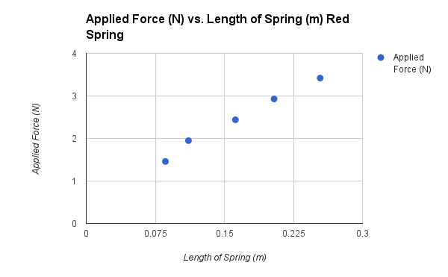

Plot 1: Applied force vs. length of spring for Red Spring taken from table 3

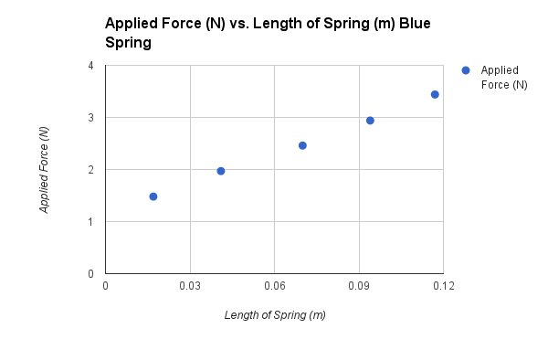

Plot 2: Applied force vs. length of spring for Blue Spring taken from table 3

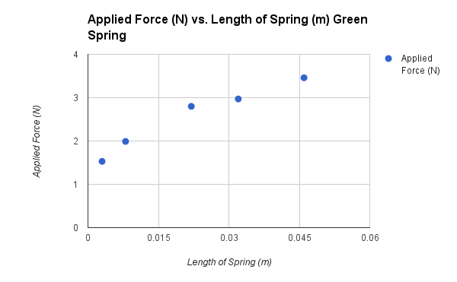

Plot 3: Applied force vs. length of spring for Green spring taken from table 3

Spring Constant

Length and Volume

Relationship to Spring Constant